

USHAHIDI CROWDMAP APPLICATION
Product Requirements Document

DOCUMENT CHANGE CONTROL

Version Number | Date of Issue | Author(s) | Brief Description of Change
0.1 | 4/14/2014 | M. McAllister | Initial document
0.2 | 4/14/2014 | A. Pease | Edits
0.3 | 4/15/2014 | M. McAllister | Incorporated Edits
0.4 | 4/18/2014 | A. Pease | Additions
0.5 | 4/28/2014 | A. Pease | Additions and Edits
0.6 | 4/28/2014 | M. McAllister | Incorporated Edits

DEFINITION

Term | Definition
PCV | Peace Corps Volunteer
RPCV | Returned Peace Corps Volunteer
PCMO | Peace Corps Medical Officer
Post | Peace Corps Country Location

PROJECT MANAGERS

Annie Pease
Pre-Service Training Coordinator, Azerbaijan
annie89pease@gmail.com

Patrick Choquette
Director of the Office of Innovation
pchoquette@peacecorps.gov

Matthew McAllister
Special Assistant, Office of Innovation
mmcallister@peacecorps.gov
Contents
DOCUMENT CHANGE CONTROL 1
DEFINITION 1
PROJECT MANAGERS 1
PLATFORMS FOR DEVELOPMENT: 3
BACKGROUND 3
PURPOSE OF THE APPLICATION: 3
PROFILE OF A USER: 3
DEVELOPER ORGANIZATION: 3
DEVELOPER SET UP 3
FUNCTIONAL REQUIREMENTS: 3
Editing Default Report FieldsFields 3
Removing Unnecessary Features 5
Change Required Field Error Validation Outcome on New Report Page 6
Constrain Map Zoom 7
Changes to Map Indicators – Multicolored and Smaller 8
Landing Page Default 9
Partial Search Not Allowed From Reports Screen 10
Options for Filtering Reports 11
Add Search Bar to HOME Tab with Local Language Support 12
Add a FAQ Page 13
Bug: Report Comments don’t Save or Display 14
Unable to Find Region on Location Drop Down Menu 15
Add an active/inactive project button to our options 17
Members need to be able to edit their own submitted reports 18
Filling Out Reports 19
Remove “Alerts” Tab and Replace with “Opportunities” Tab 20
Add Notifications 21
Allow admin to add small subtext under field prompts 22
Add Azerbaijani character options under each search bar 23
Search Option for Downloading Reports 24

PLATFORMS FOR DEVELOPMENT:

BACKGROUND

PURPOSE OF THE APPLICATION:

Peace Corps Volunteers in Azerbaijan are attempting to use Ushahidi to better coordinate their efforts and share identified resources with each other more efficiently. The project leads started experimenting with Crowdmap Classic by having a number of test volunteers try it out. Through that process they have identified a list of customization's that would help increase usability within their users.

PROFILE OF A USER:

The typical user would be a PCV in a village or town in any region across Azerbaijan. PCVs are all Americans with diverse backgrounds and work experience. They range from 21 to 70+ years old. The average PCV is familiar with email and social media but is not very tech savvy beyond that point. Most use basic Nokia cell phones although smart phones are becoming more common especially amongst younger/middle aged volunteers. Most users have little to no experience with crowdsourcing information.

DEVELOPER ORGANIZATION:

GitHub
https://github.com/PeaceCorps/PCAZ

Current Live Site:
https://pcaz2.crowdmap.com/

DEVELOPER SET UP

FUNCTIONAL REQUIREMENTS:

Editing Default Report FieldsFields
GitHub: https://github.com/PeaceCorps/PCAZ/issues/1
Can we edit the default fields that come with the forms? When we go to our dashboard, we can edit the form fields. However, there are 2 default and required fields titled, "Report Title" and "Description". These two fields cannot be modified or deleted by the site administrator. The administrator goes to Manage > Forms, to edit these fields. The administrator needs to have the ability to modify or delete all fields on a New Report screen.

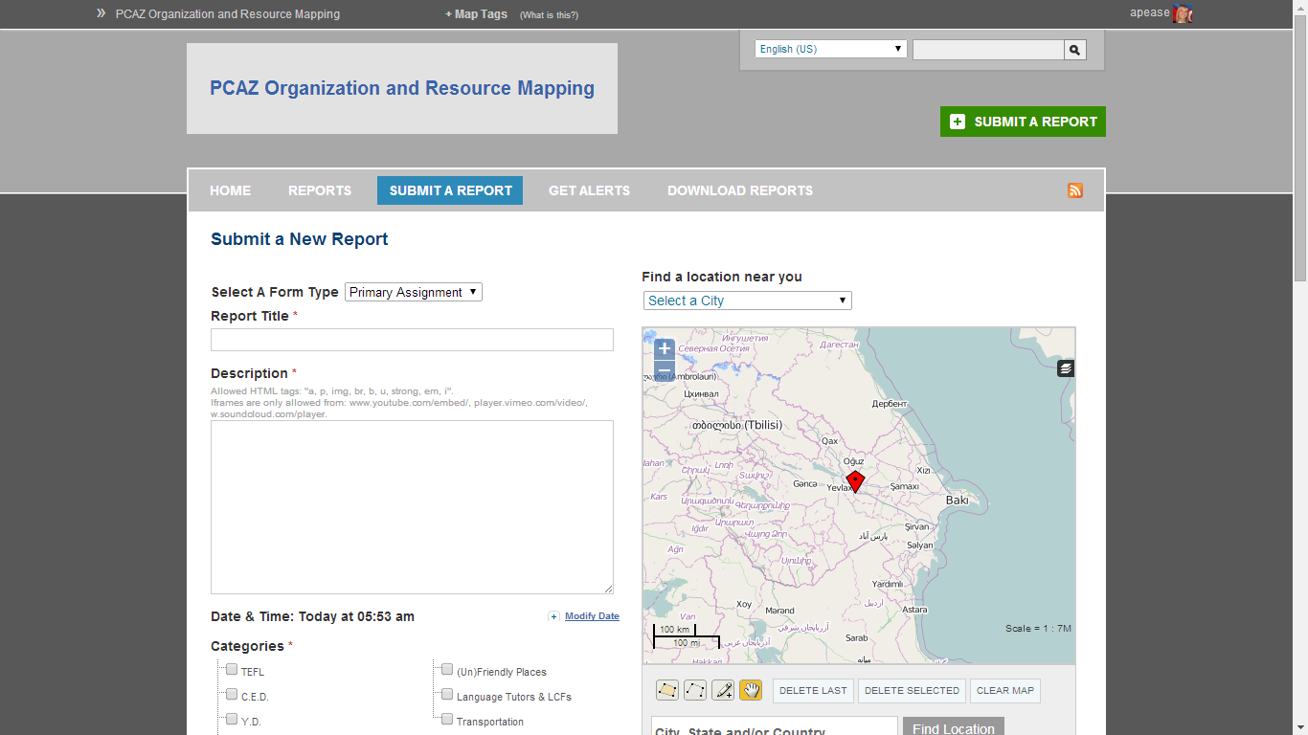
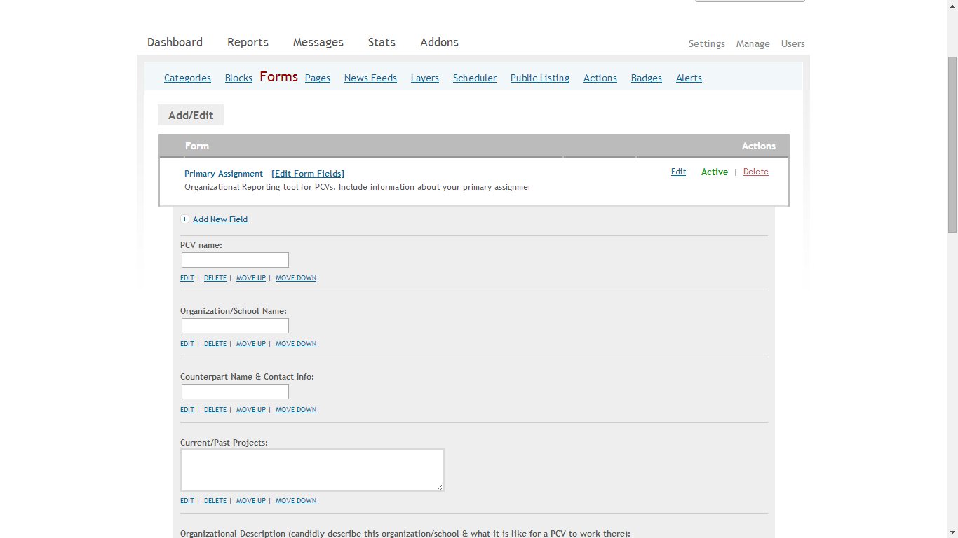
The form the user sees should be a perfect match to the Edit Form screen the Administrator is able to edit. The screenshot of the edit fields above should be the only fields the end user sees.
No “report title” or “description”

Removing Unnecessary Features
GitHub: https://github.com/PeaceCorps/PCAZ/issues/12
*Need to update GitHub

Because most of the people using this site are Peace Corps Volunteers with weak internet signals, we want to eliminate any excessive features whose inclusion slow down the site. The following specific steps should be taken:
  - Disable any smartphone features including push notifications.
  - Remove search by filters on the main page:
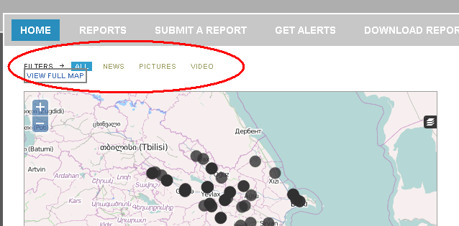
  - Delete chronological reports list, submission interval tracker under the map, “How to report” options and social sharing links on the homepage
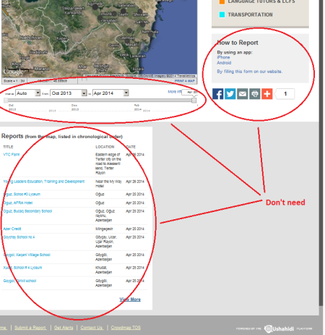
  - Delete “submit a report” tab on the home page. NOT green button, but the tab. Also remove “hide” option for the category filters. We want that category key permanently on the home screen.
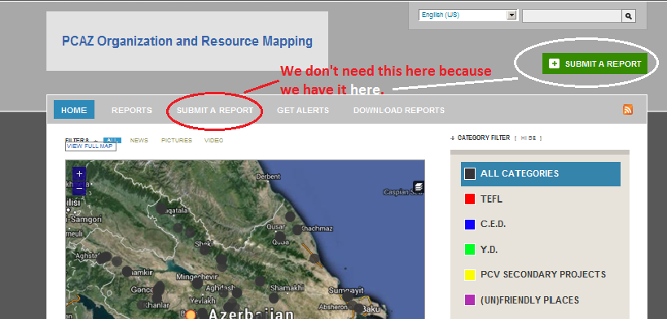

We want the interface to be as user-friendly as possible. Less is more!

Change Required Field Error Validation Outcome on New Report Page
GitHub: https://github.com/PeaceCorps/PCAZ/issues/10

Ensure that if a user fails to complete all required fields, data they have entered isn’t lost on the Add New Report screen.

When submitting a report, if I select the form "secondary project" (which is not the default form on the 'submit a report page'), and then fill out the report but forget to fill out one of the mandatory fields (*), the page reloads with an error message indicating my mistake:

The problem is that in the process of reloading, this form reverts to the default "primary assignment" form (even though "secondary project" is still shown in the drop-down menu), and all the previously inserted information on the "secondary project" form is lost.

Can we change this so that if a mandatory field form is blank when someone submits the report, the page doesn't reload and default to a different form, but just displays an error message notifying the user to fill in the mandatory field. I don't want anyone to lose information they wrote on the forms.

Constrain Map Zoom
GitHub: https://github.com/PeaceCorps/PCAZ/issues/2
*Need to update GitHub

Is there any way we can constrain the "zoom" feature on the maps (on all parts: when on the home page, when creating reports and when looking at established reports). Volunteers get confused when they're scrolling down the page and if the mouse goes over the map, instead of the page scrolling, the map zooms way in or out. This is challenging for people who don't know that the map is also sensitive to the scroll feature. Constraints would be helpful.

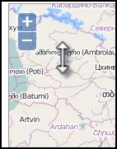

For bandwidth reasons, we also want to constrain the zoom so that you can’t zoom out any further than Azerbaijan. We don’t need the full map of the world, only Azerbaijan’s map. This may be a feature we’d want to make selectable for PC-wide applicability. If other PC posts use Crowdmap, there could be some kind of dropdown menu where they could choose their country and the map would constrain based on their selection.

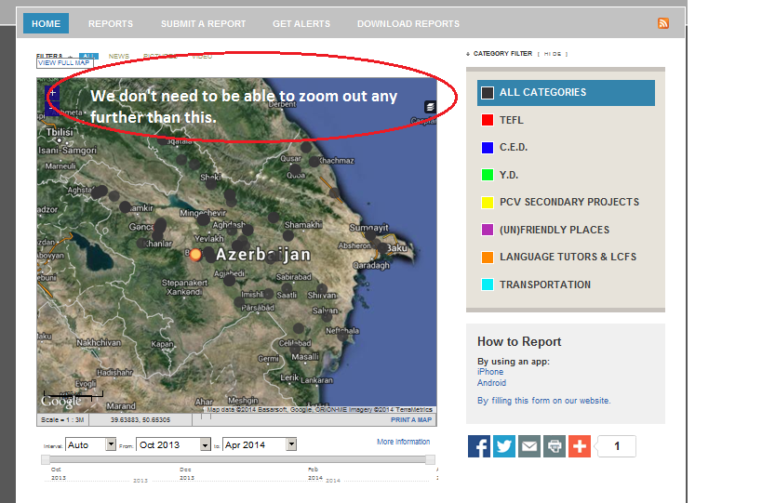

Changes to Map Indicators – Multicolored and Smaller
GitHub: https://github.com/PeaceCorps/PCAZ/issues/3
*Need to update GitHub

On the home screen, there are black dots that represent "all categories." Is there any way we can remove the "all categories" option and just have all the dots multicolored on the home screen to represent each category with their assigned colors? We’d also like to make these dots smaller. We’d like them to be 50% of their current size.

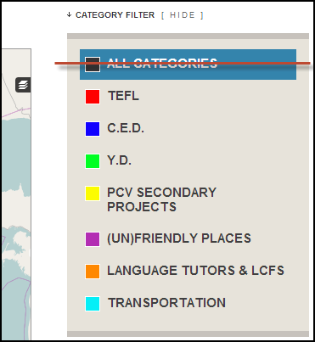

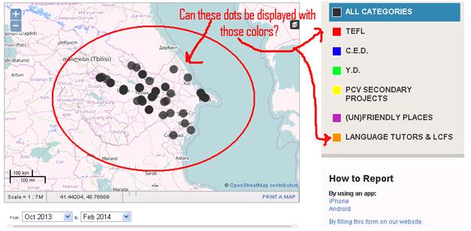

Landing Page Default
GitHub: https://github.com/PeaceCorps/PCAZ/issues/4

When members log in, they are automatically directed to their personal dashboard page. They have to click on the upper left hand link to get to the Azerbaijan map. Is there any way we could make the first page (after log-in) the screen with the map? Member dashboard default URL is: https://pcaz2.crowdmap.com/members/dashboard, the default landing page should be the HOME tab: https://pcaz2.crowdmap.com/.

Partial Search Not Allowed From Reports Screen
GitHub: https://github.com/PeaceCorps/PCAZ/issues/5

From the home screen, when you click on the "Reports" tab, you can search the reports through different filters. One of the problems we have is when you search with custom fields, you can't search the report title (automatically generated prompt by Crowdmap), and if you search under "name of secondary project," you have to include each word. For example, one of the titles of a secondary project is Eyyublu Softball Team, and if I search "Softball" nothing comes up. I must search "Eyyublu Softball Team" for Crowdmap to find that report. The search needs to support partial word searches.

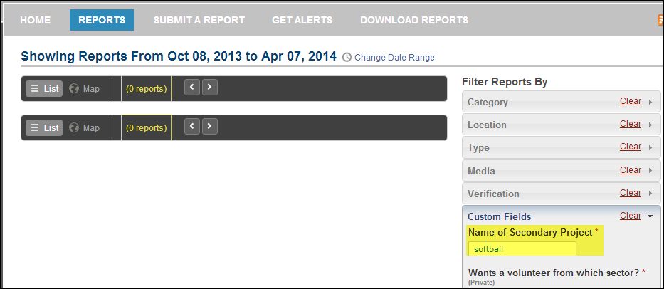

Options for Filtering Reports
GitHub: none

From the home screen, when you click on the "Reports" tab, you can search the reports through different filters. We want to customize the “filter reports by” option. We like the category option.
  - We want to add, under the location option, the ability to search by city name.
  - We want to eliminate Type, Media and Verification filters.
  - Under Custom Fields, we want to clean up the filter options there. We want to limit the options to just: PCV name, contact name (any name that has been listed in the reports as a counterpart, director or contact person), and key words.

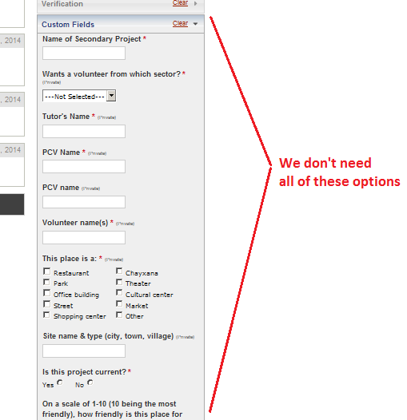

Add Search Bar to HOME Tab with Local Language Support
GitHub: https://github.com/PeaceCorps/PCAZ/issues/5
*Need to update GitHub

On the HOME Tab, a search bar should be added that searches the contents of all reports. Search terms should be allowed in Azerbaijani or English. The search should allow for partial search terms, and the map that appears on the HOME tab should dynamically update to match the search results table that generates below the search entry box.

A search bar should replace the timeline feature, as indicated in the picture below. We’d also like to make sure that this search option is visible on the screen immediately when the user loads this page without having to scroll down. That may mean eliminating some of the gray space at the top of the screen. The most important things for users to be able to see upon login are the: 1) actual map 2) submit a report button 3) search bar 4) categories. We want those very easy to find. Overall, we think this page looks a bit outdated. It reminds us of Windows 98 and we want to hook our users with something more innovative. Any ideas/suggestions you have to do that here are welcome.
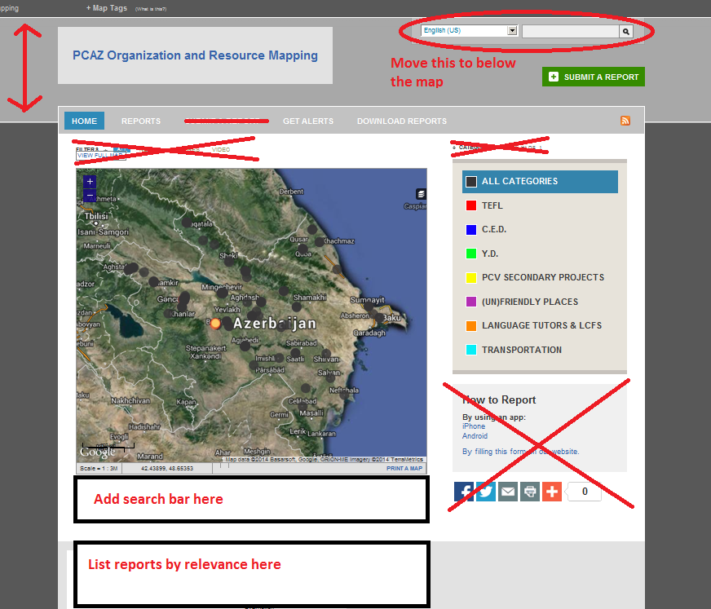

Add a FAQ Page
GitHub: https://github.com/PeaceCorps/PCAZ/issues/6

Can we add an FAQ page?

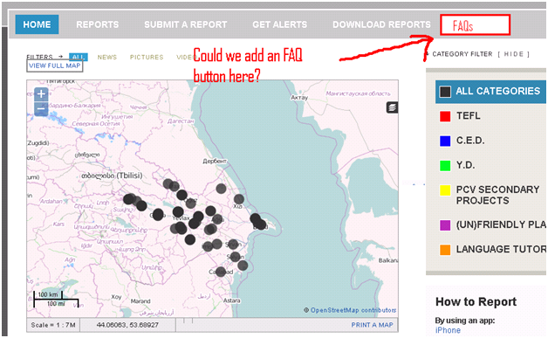

Bug: Report Comments don’t Save or Display
GitHub: https://github.com/PeaceCorps/PCAZ/issues/8

What happens to the comments when a member makes a comment on another member's report? We've tried this, and the comments don't seem to show up anywhere.
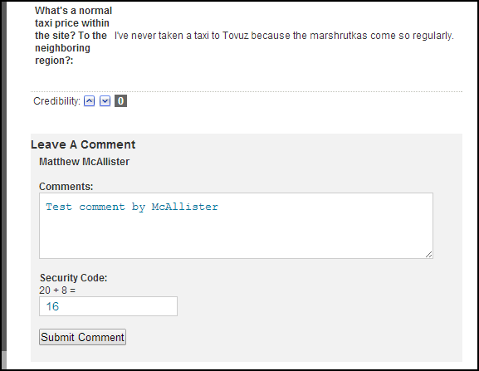



Unable to Find Region on Location Drop Down Menu
GitHub: https://github.com/PeaceCorps/PCAZ/issues/11

When volunteers are submitting a report, and they're looking for their region on the drop down menu above the map on the right hand side of the page (so they can place a pin), some people are confused when they can't find their region. Most of the regions are on that list, but many are not. Could we add to that? I think that list is generated by how the open street map layer is labeled, but even some of the towns on the map didn't make the drop down list. It would be helpful too if we could add text there to explain that they can select their region there from the drop down menu and then add their village name below. GitHub: https://github.com/PeaceCorps/PCAZ/issues/11

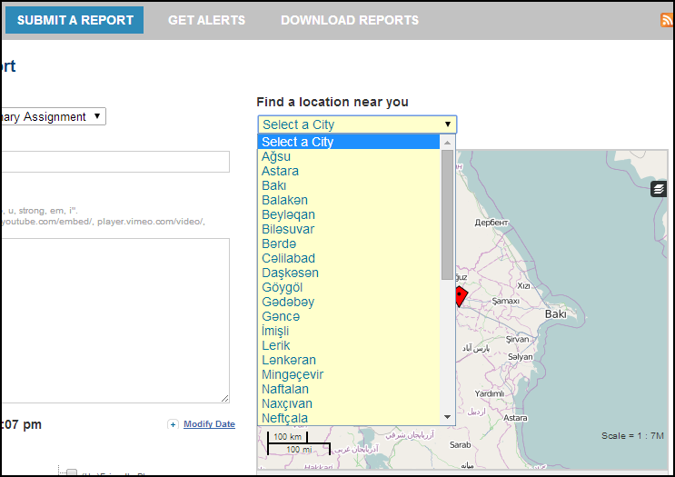

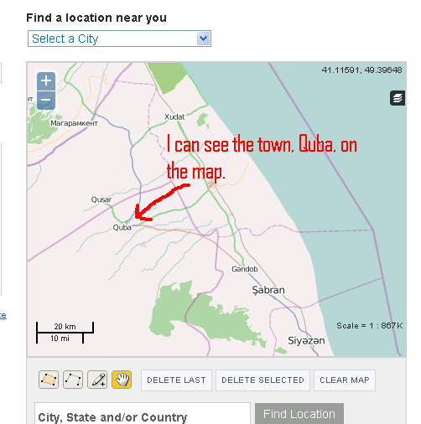

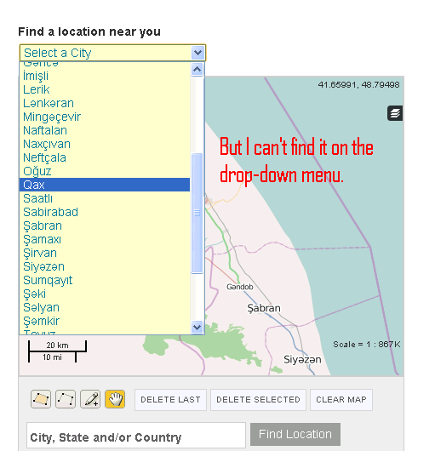

Add an active/inactive project button to our options
GitHub: https://github.com/PeaceCorps/crowdmap/issues/13

We’d like to add a feature where you can see on the home screen which projects are active and which projects are inactive by a quick glance at the map. Our idea is to have the active projects in a bold, bright color and the inactive projects faded so you can still see that they’re there but they don’t grab your attention right away.

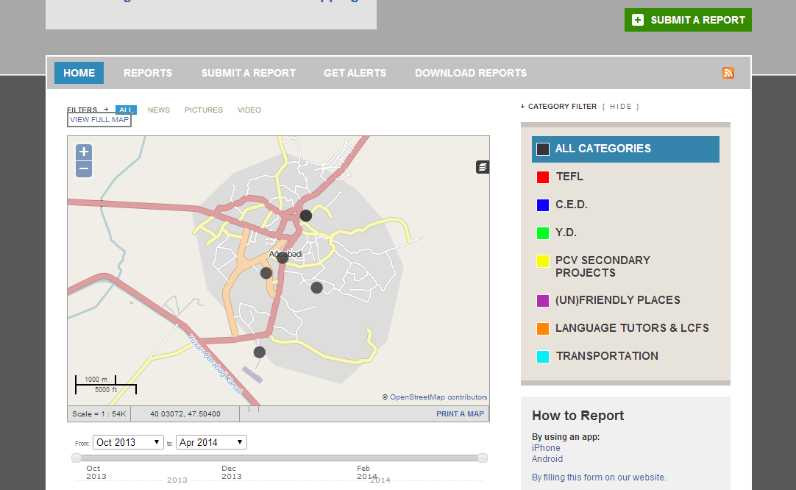

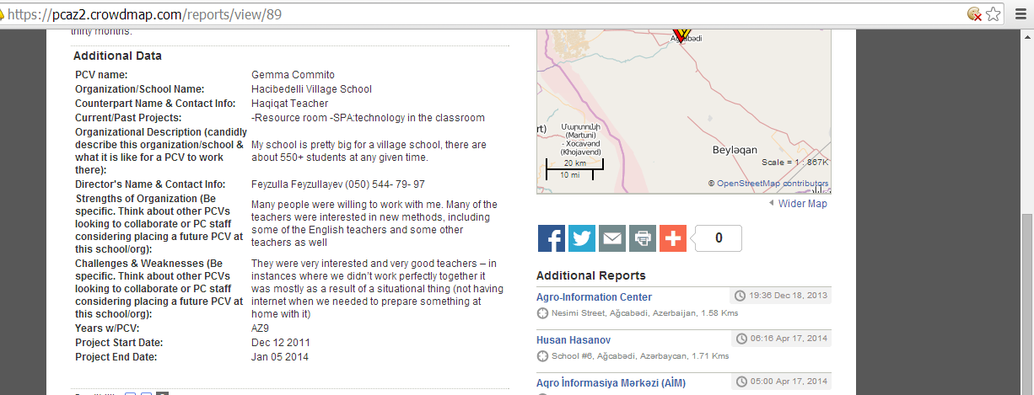

For example, this is no longer an active project. Could we make its dot on the home screen faded?

Members need to be able to edit their own submitted reports
*Need to add to GitHub

After submitting a report, a member cannot go back and edit it. Administrators can, but users with “member” status cannot edit their own reports. This should be changed so that members can edit their own reports.

Filling Out Reports
*Need to add to GitHub

When members are filling out reports, there are a few things we’d like to customize.

- We’d like users to be able to upload pictures, but we don’t want anyone to upload a video or picture that is so big, that it would slow down the site. We don’t want to use too much bandwidth on for multimedia.

- When using the calendar feature to list project start and end date, PCVs have to click up to 24 times to indicate a project whose length lasts 2 years. Could we change that so it’s easier to choose start and end dates for long projects? We’d like this calendar feature to link to the main screen to display current vs. inactive projects.
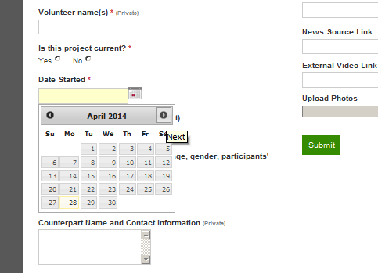
- We’d like the field boxes to automatically expand once clicked on for better visibility when typing in several lines of information (it’s difficult to see how much/what you’ve already typed) and return to regular size once finished. If this box popped out while you were typing so you could see the whole thing, you’d be able to organize your information better.
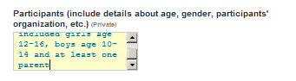

Remove “Alerts” Tab and Replace with “Opportunities” Tab
*Need to add to GitHub

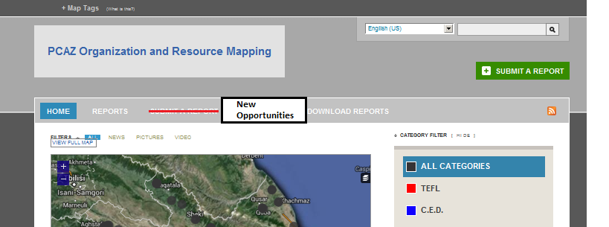
Opportunities

Opportunities tab: screen divided into two sections.
In Search of | Resources Available
Reports that have information in the “In search of” section will be filtered into this tab.  The idea is that volunteers who need resources for a specific project will indicate that while filling out their form for that project. The report will be posted here, highlighting the items being sought. | A link to fill out a separate form will be posted here. (A button labeled “I have resources!” or something similar). PCVs will click that button and fill out this form if they have resources (manpower, trainings or physical things) that they want to make available to other PCVs.  A compiled list of those available resources will be posted here.

The idea is that this page will act as a mini “Craigslist” for PCVs to see what other volunteers have and post what they are looking for.
I have resources!
PCV or committee name:

Resources available:

Available from: insert date range

Additional info:

Add Notifications
*Need to add to GitHub

We’d like to add the feature that whenever a member logs in, he/she can see a notification for how many reports have been submitted since his/her last log-in. The idea is that this would be the first screen a user sees when he/she logs in. Then he/she’d also be able to see (just like facebook) how many updates have happened since he/she logged in last. Once the user clicks on and views the reports tab, the notifications would go away. The same concept would apply to the “new opportunities” tab whenever another user posts an ‘in search of’ or ‘resource available’ item.

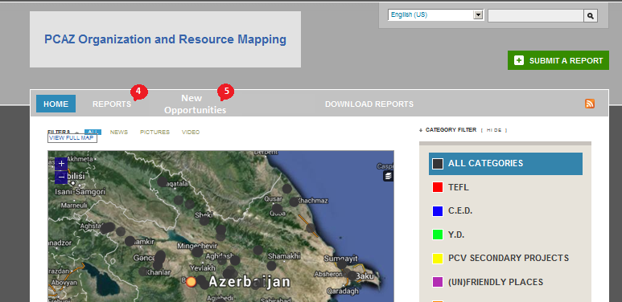

Allow admin to add small subtext under field prompts
*Need to add to GitHub

When the admin is editing her forms in the “manage” > “forms” tab, we don’t want to put the explanation for a field in parenthesis. We’d like to have an option to put the explanation in smaller text and maybe a lighter color under the prompt.

Instead of this:
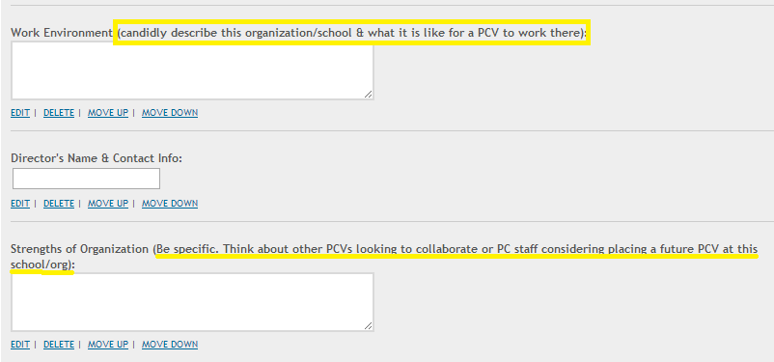

We’d like to have to have the option to post something that looks more like this:
///
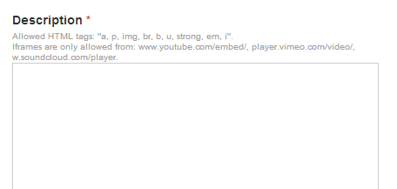

Add Azerbaijani character options under each search bar
*Need to add to GitHub

In order to facilitate searches in Azerbaijani language, it would be ideal if we could have the Azerbaijani characters underneath location search bars such as:

Put these:

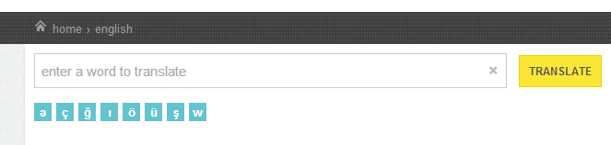///

Here:

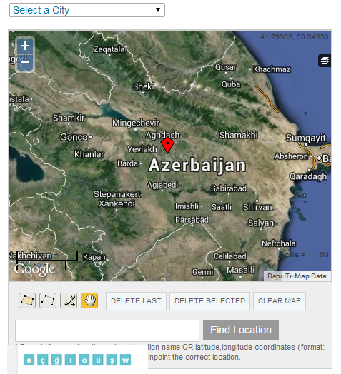/

It’s most important on the home page search bar as well as under the map when finding the location while filling out reports.

Search Option for Downloading Reports
*Need to add to GitHub

I’d like to discuss the options we have with the “download reports” tab. The excel file created when you download the reports as CSV files in Excel is very messy. We’d like to make that more user friendly if possible. We’d also like to make a custom search option so you can download reports when you search by keyword instead of only by category.



